**Cheaper diesel & petrol for your business!**

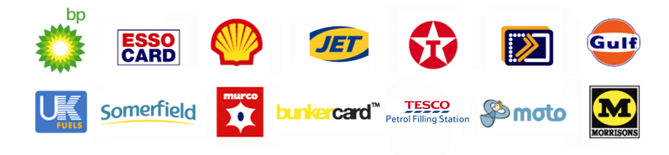  


**Refuel your ambulance at up to 4p per litre below pump prices**

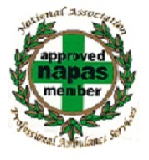

If you haven’t got a fuel card yet, you could be paying more for fuel than other UK businesses.

If you already have one, call The Fuelcard People on   
**0844 870 9856** for a FREE Instant Fuelcard Audit – it only takes a few moments, costs nothing and will compare our fuel cards to check that you have the best possible deal.

The Fuelcard People delivering cost savings to fuel card users throughout the country

You’re not very far from your nearest discount diesel or petrol   
– and there are thousands of cheap refuelling sites nationwide. All you need is a fuel card from The Fuelcard People.

Complete and fax back the enquiry form overleaf and you’re on the way to cheaper fuel. We’ll call to find out which fuel card suits you best – BP, Esso, Shell, Texaco, and more – from the UK’s widest range, then run a routine credit check.

Within days, you’re refuelling at a discount and presenting your fuel card; it’s like using a credit card, but without the interest charges. And, there’s no security worries, less administration hassle, easy VAT reclaiming and full Internet account management services.

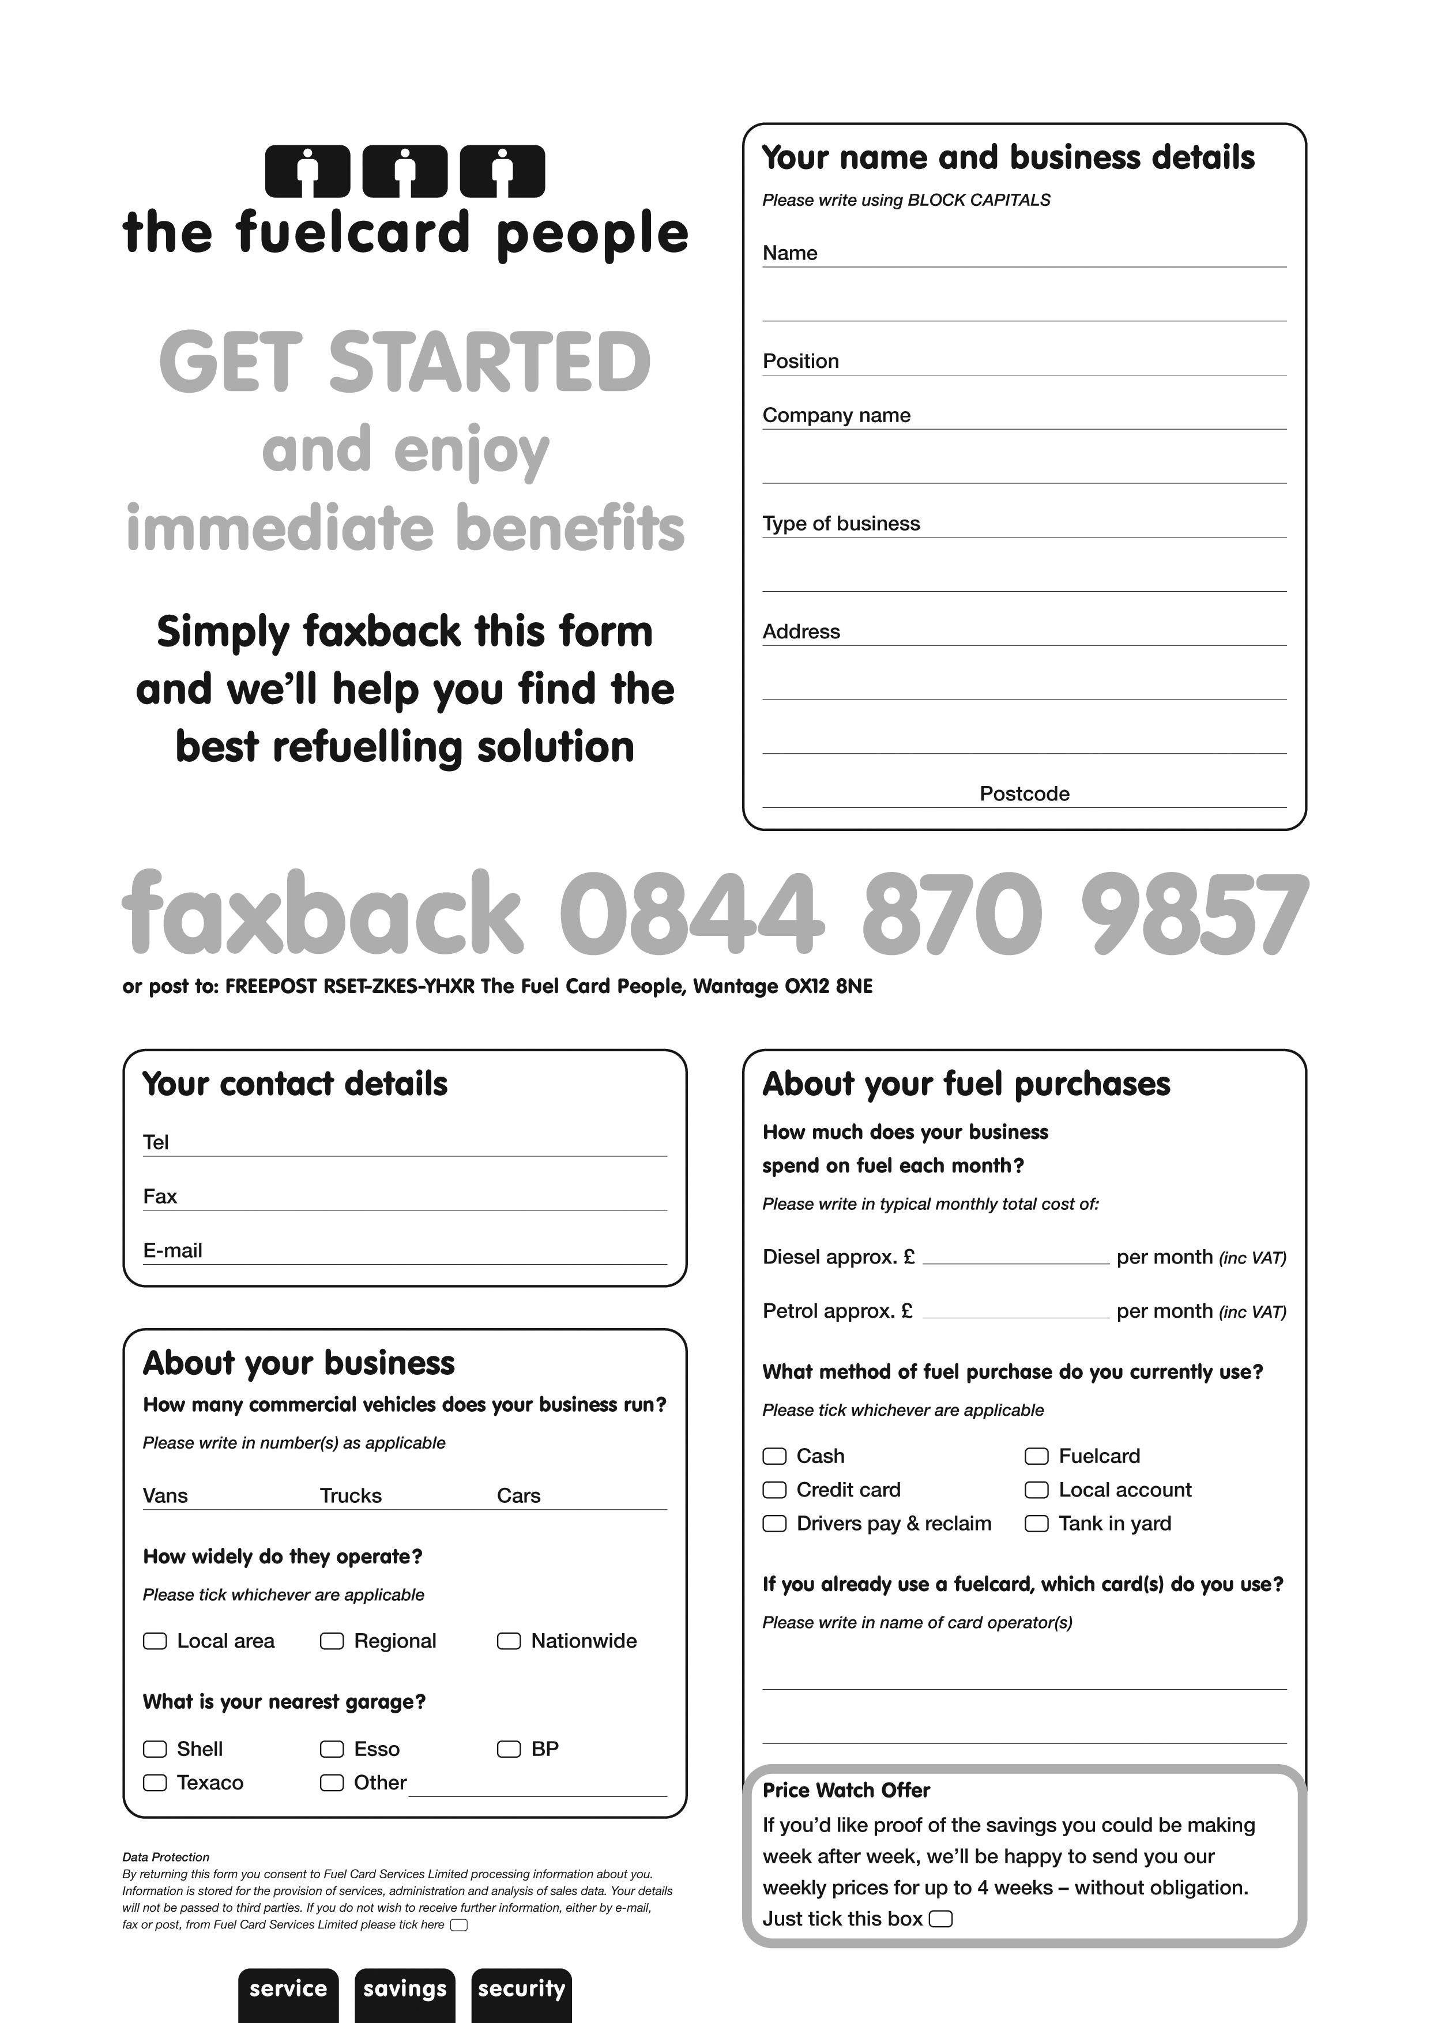

**NAPAS**